Mepilex Transfer Ag:
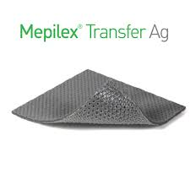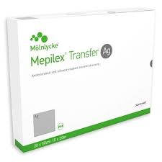

INTERNAL Workday Ordering Information and Cost (Atrium Market):
SMALL SIZE (8” x 6”):
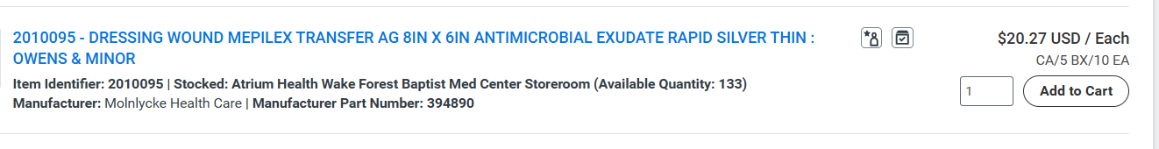
LARGE SIZE (20” x 8”):
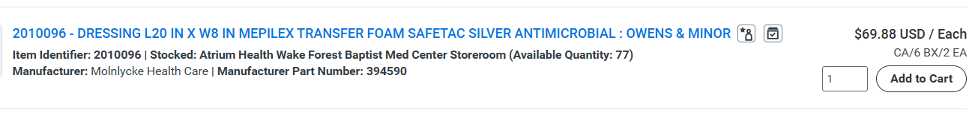
VIDEO LINK:
This video demonstrates application of the Mepilex Transfer Ag Dressing on a burned arm. The process would be the same for application to burns on other parts of the body. This dressing is NOT to be used on the FACE.
Burn Center | Atrium Health Wake Forest Baptist

“One Pager” Information / TIP Sheet for Mepilex Transfer Ag included below.
Mepilex Transfer Ag
**Be sure you are following orders as written, these are meant as a guideline**

  - Indicated for partial thickness burn injuries.
  - Please debride the burn wounds prior to applying this dressing.
  - Do NOT place anything under the Mepilex Transfer Ag. It needs to be in direct contact with the burn wounds to work properly.
  - Do NOT discard- It is good to use for approximately 14 days.
  - Bathing is expected of the patient, plan for a shower or bath every other day (at minimum).
  - Take the Mepilex Transfer Ag off to bathe.
- Place the piece(s) off to the side on a clean area while bathing.
- After bathing, pat wounds dry and reposition the Mepilex Transfer Ag back on top of the burns. Sticky side DOWN to the wound bed!
- DO NOT WASH OR RINSE the Mepilex Transfer Ag
  - The Mepilex Transfer Ag absorbs drainage. It may begin to look “dirty” and it may develop an odor. This is normal.
  - Replace the outer dressings that are holding the Mepilex Transfer Ag on the burns every time the patient bathes or the dressing is removed. Outer dressings can include kerlix, burn net, etc.

